Why the Mets' offense is a big problem heading into the playoffs
Following the team’s series loss to Washington over the weekend, the year-long questions about the Mets’ offense have grown louder and more persistent

The Mets are one of the most confounding good teams in baseball this season.

Everyone knows they pitch well, yet their bullpen is suspect, yet their closer is outstanding.

More confusingly, their run stats do not seem to match the eye test.

Heading into the finale against Washington, the Mets as a team were sixth in the Majors in runs scored, fifth in wRC+, seventh in wOBA (per FanGraphs), eighth in OPS, third in OBP, seventh in batting average, second-best in strikeout rate, fourth in WAR, and seventh in hits.

At the same time, they’re 16th in home runs, 17th in ISO, 11th in SLG, 14th in walk rate, 12th-highest in groundball rate while only 22nd-highest in fly ball rate, 18th in HR/fly ball ratio, and 26th in hard-hit rate.
Obviously, baseball is a game of creating runs. A team that’s sixth in the Majors in doing just that has to be doing something right, especially when that’s combined with a fifth-best wRC+ to back it up. They have the National League’s second-leading RBI man.

Still, following back-to-back one-run performances against the lowly Nationals, Mets fans are fearing a repeat of 2007-08 as they’ve seen their team’s division lead dwindle to a single game. The goodwill engendered by taking two out of three from baseball’s best team is but a dim memory after the disaster of consecutive shellackings (yes, GKR, shellackings).

While large segments of Mets Twitter foretell the doom of “same old Mets,” others push back with all the cumulative batting stats mentioned above together with the team’s 85-50 record. Baseball ebbs and flows, they say. This was the first blip on the radar against a bad team, they argue.

However, there is legitimate reason to worry about the Mets’ offense in the midst of a sluggish three-week run that culminated in the back-to-back one-run showings against pitchers with ERAs north of 5.00.

Runs scored breakdown
While cumulative runs scored obviously tell a story, they’re missing context. If a team explodes for 13 runs in one game but scores 2 runs in its next three, chances are they’re going to have gone 1-3 in those games - even though the runs scored average is almost five runs per game.

Since the Braves are nipping at the Mets’ heels in the division, let’s compare a different aspect of the teams’ run-scoring prowess. While Atlanta is second in the Majors in runs scored and had scored 41 more runs heading into Sunday’s game, that still doesn’t seem like such a significant difference to be worried, at 0.3 runs per game.

However, it’s the breakdown of how many runs these teams have scored game in and game out that explains why Atlanta’s offense seems so much more dangerous than the Mets’.

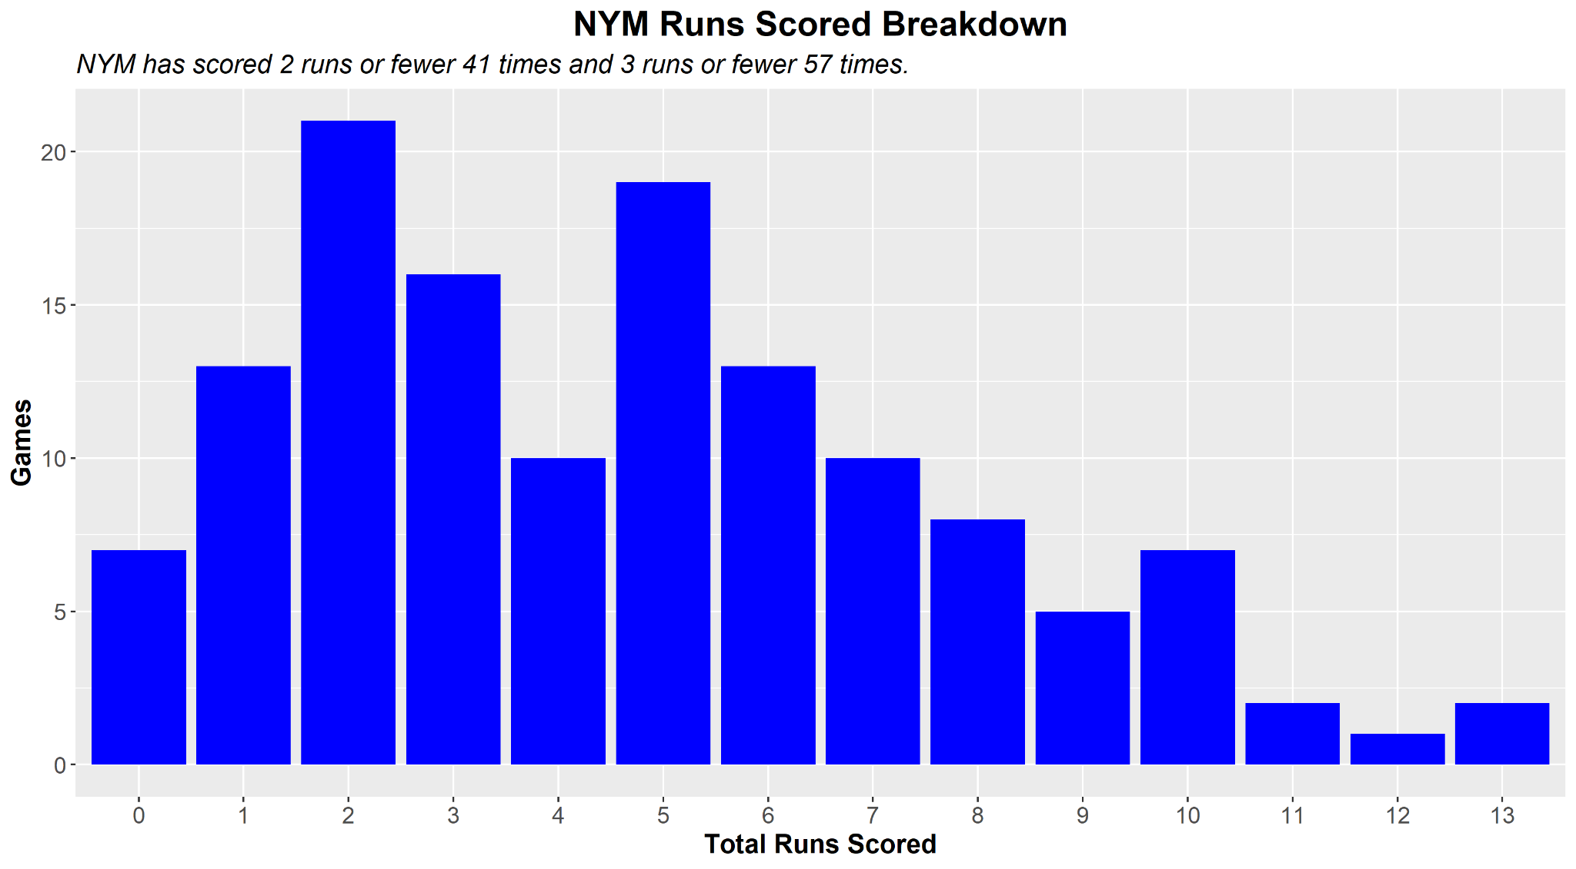
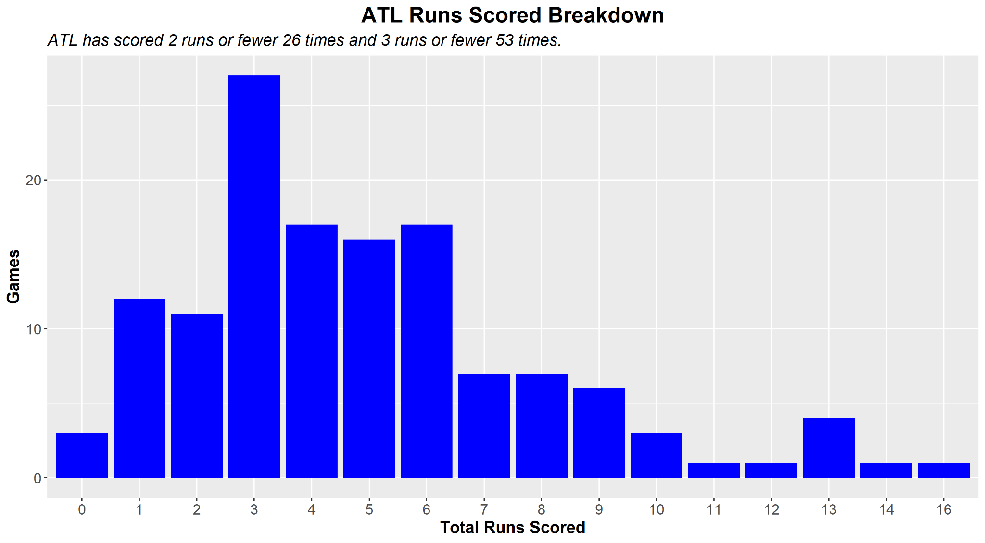

At a quick glance, we can see that Atlanta has scored two runs or fewer only 26 times, while the Mets have done so 41 times. Although the numbers get closer to even when you account for three runs or fewer, the fact that the Mets score two runs or fewer 30% of the time is alarming. That means that their pitching must be flawless for them to win the game. Even with starters like DeGrom and Scherzer and a closer like Diaz, that leaves almost no margin for error.

Furthermore, let’s take a look at the teams’ records in those games. When the Mets score two runs or fewer, they are 5-36 (.122). When they score three runs or fewer, they’re 14-43 (.246). Meanwhile, when Atlanta scores two runs or fewer, their record is 5-21 (.192). When they score three runs or fewer, they’re 18-35 (.340).

Comparing the winning percentages when the Mets and Braves score three runs or fewer is alarming. Although the quantitative number is similar (57 Mets, 53 Braves), the results are startingly different. Atlanta is 14.8% better than the Mets in those situations, which is quite significant. This means that when you combine hitting and pitching, Atlanta can get it together far more than the Mets when their offense does not break through.

Let’s extend this study to all the teams currently in playoff position in the National League.That makes six teams - the Mets, Braves, Dodgers, Cardinals, Phillies, Padres.

Team | Record when scored <= 2 runs | Record when scored <= 3 runs | Record when scored 4+ runs | Record when allowed <=2 runs | Record when allowed <= 3 runs | Record when allowed 4+ runs
Mets | 5-36 (41, .122) | 14-43 (57, .246) | 71-6 (77, .922) | 43-8 (51, .843) | 58-13 (71, .817) | 27-36 (63, .429)
Braves | 5-21 (26, .192) | 18-35 (53, .340) | 65-16 (81, .802) | 49-3 (52, .942) | 64-9 (73, .877) | 19-42 (61, .311)
Dodgers | 5-20 (25, .200) | 12-31 (43, .279) | 79-10 (89, .888) | 54-5 (59, .915) | 71-10 (81, .877) | 20-31 (51, .392)
Cardinals | 6-28 (34, .176) | 11-37 (48, .229) | 67-18 (85, .788) | 37-6 (43, .860) | 57-12 (69, .826) | 21-43 (64, .328)
Phillies | 6-31 (37, .162) | 12-41 (53, .226) | 61-19 (80, .763) | 42-7 (49, .857) | 54-11 (65, .831) | 19-49 (68, .279)
Padres | 10-35 (45, .222) | 19-44 (63, .302) | 55-16 (71, .775) | 43-3 (46, .935) | 52-11 (63, .825) | 22-49 (71, .310)
Averages | 6.2-28.5 (34.7, .179) | 14.3-38.5 (52.8, .271) | 66.3-14.2 (80.5, .824) | 44.7-5.3 (50, .894) | 59.3-11 (70.3, .844) | 21.3-41.7 (63, .338)

Comparing the Mets to other playoff teams, a trend emerges. The Mets are below average, sometimes significantly so, in most of these categories. The only areas of this run breakdown in which the Mets are well above average is when they score four or more runs and when they give up four or more runs. Since the former has been announced ad nauseam on the Mets’ broadcasts, it’s no secret that when the Mets score four or more runs, they win. The second is surprising, though: the Mets have a good record when they surrender four or more runs?

That leads to a conclusion which Jacob DeGrom has long known: the Mets do not back up their great pitching performances. Consider that the Braves are a full 10% better than the Mets when they allow two or fewer runs, though the number of times that has happened for each team is similar. The Dodgers are also far stronger than the Mets in that situation. In fact, among those in playoff position in the National League, the Mets have the worst win percentage when their pitching allows two runs or fewer. Ironically, despite the fact that they have a strong starting five and an elite closer, they have actually given up two runs or fewer the second-fewest times of the six current playoff teams (although the numbers are close). This highlights the shakiness of the team’s bullpen relative to the other playoff teams, weakening and perhaps negating the Mets’ pitching advantage.

The Mets are also the worst when allowing three runs or less, but the number isn’t quite as stark. They’re certainly pretty close to the Padres and Cardinals and not too far off from the Phillies. Perhaps when they surrender three runs, their offense finally decides to wake up. They have also surrendered three runs or fewer the third most times among playoff teams, but of course, their two main competitors in the division and league are ahead of them - the Braves and Dodgers.

Going back to the comparison we made between the Mets and Atlanta earlier, it’s evident that the Braves are far stronger than other teams when their offense scores three runs or fewer. A .340 win percentage in that situation is very high (perhaps because the majority of those situations have been games in which they scored three runs as opposed to zero, one, or two). Still, when you look at those differences when the team scores two runs or fewer, you see that the Mets are by far the worst of any playoff team in that situation, despite the fact that they’ve scored two or fewer the second-most times. That’s highly troubling for the Mets, especially considering their recent offensive fugue. When they score two runs or fewer, their pitching usually cannot bail them out. This speaks directly to the weakness of the Mets’ bullpen, but also to the fact that many of the playoff teams have strong pitching staffs, perhaps deeper overall than the Mets’.

The question remains: why are the Mets better than other teams when they either score or allow four runs, but generally weaker otherwise? The scoring part seems attributable to their pitching, since four runs is usually enough for the starters and bullpen to get the game to Diaz with a lead. The four runs allowed is very surprising and cannot be attributed to just a few games. It seems that the Mets can hang with teams in a shootout, at least relative to the other NL playoff teams.

Playoff outlook
Obviously, there is still a month for the Mets to get their act together. Perhaps Pete Alonso will find his late-July form once again. Maybe Daniel Vogelbach will recapture the magic from his first few weeks in New York. It’s possible that somehow James McCann and Eduardo Escobar will start to hit closer to their career norms rather than their season-long funks.

Still, in the long run, the Mets are who they are offensively. They go ice cold at times. They have a hard time backing up their aces. Their lack of consistent home run power often kills their run potential despite many hits and high on-base percentage. What’s most troubling is that their pitching does not seem to be able to consistently pick up their hitting, at least compared to the other playoff teams.

With Joey Lucchesi and Tylor Megill nearing returns, perhaps the bullpen will find its footing late. But with Taijuan Walker and Carlos Carrasco looking shaky down the stretch and the already-vulnerable rest of the bullpen besides Diaz (and perhaps Ottavino, overall), it’s fair to wonder if the Mets can get anywhere in the playoffs at all.

Fans and analysts have pointed to the team’s cupcake September schedule as a reason to be optimistic. However, this series against the Nationals put a large question mark on the narrative, and the inability to score runs against bottom-of-the-league pitchers makes the October questions even louder.

Perhaps the dominance of Scherzer, DeGrom, and Diaz can get the Mets through September and carry them deep into October. However, the season trends are worrisome as the team’s division lead hangs in the balance.

